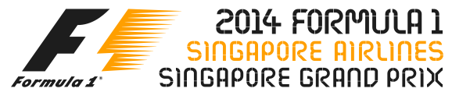

ANNEX 1 – 2014 FORMULA 1 SINGAPORE AIRLINES SINGAPORE GRAND PRIX ENTERTAINMENT SCHEDULE*

DATE | ARTISTE | LOCATION | TIME
19 September  Friday | Mayday  @Mayday_EN  #Mayday五月天‬‬‬‬‬‬‬‬‬ | Padang Stage  (Zone 4) | Post  Formula One™ Practice
20 September  Saturday | Pet Shop Boys  www.petshopboys.co.uk  @petshopboys | Village Stage  (Zone 1) | Pre  Formula One™ Qualifying
20 September  Saturday | Ziggy Marley  http://ziggymarley.com  @ziggymarley | Village Stage  (Zone 1) | Post  Formula One™ Qualifying
20 September  Saturday | Robbie Williams  http://robbiewilliams.com  @robbiewilliams | Padang Stage  (Zone 4) | Post  Formula One™ Qualifying
21 September  Sunday | Ziggy Marley  http://ziggymarley.com  @ziggymarley | Esplanade Outdoor Theatre (Zone 4) | Pre  Formula One™ Race
21 September  Sunday | John Legend  www.johnlegend.com  @johnlegend | Village Stage  (Zone 1) | Pre  Formula One™  Race
21 September  Sunday | Jennifer Lopez  www.jenniferlopez.com  @JLo | Padang Stage  (Zone 4) | Post  Formula One™  Race

* Artiste line-up, performance dates and stage venues are subject to change. The latest entertainment schedule will be updated periodically on www.singaporegp.sg.

